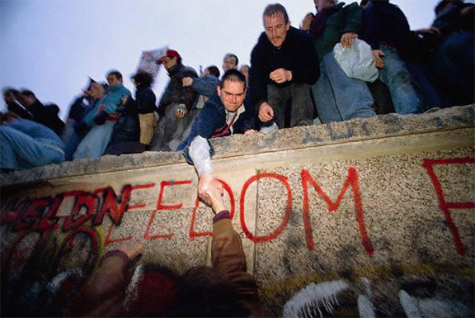

The word “freedom” was written on the wall years ago, and finally this plea is being answered.

People have already begun chipping away at the wall eager to move past the problems that arose because of it.

After 29 years the Berlin Wall will finally be torn down. Residents of Germany rushed to the wall with joy when they heard the news of reunification.